DAY-9

Task1.What are exceptions ?
Exceptions are objects that represent unusual situations that can occur during program execution.
Task2.Different types of exceptions ?
Types of Exceptions:
Checked Exceptions:
These exceptions are checked at compile time and must be handled by the programmer using try-catch blocks or declared in the method signature using the throws keyword. Examples include IOException and SQLException.
Unchecked Exceptions:
These exceptions are not checked at compile time and are usually the result of programming errors. They do not need to be explicitly handled. Examples include NullPointerException and ArrayIndexOutOfBoundsException
Task 3:

Can you try the below code snippet and let me know which kind of exception is this ?

What is the output of the code..?

// Java program to demonstrates handling
// the exception using try-catch block
import java.io.*;

class Geeks {
public static void main(String[] args)
{
int n = 10;
int m = 0;

try {

// Code that may throw an exception
int ans = n / m;
System.out.println("Answer: " + ans);
}
catch (ArithmeticException e) {

// Handling the exception
System.out.println(
"Error: Division by zero is not allowed!");
}
catch (ArithmeticException e) {

// Handling the exception
System.out.println(
"Error: Division by zero is not allowed!");
}
finally {
System.out.println(
"Program continues after handling the exception.");
}
}
}
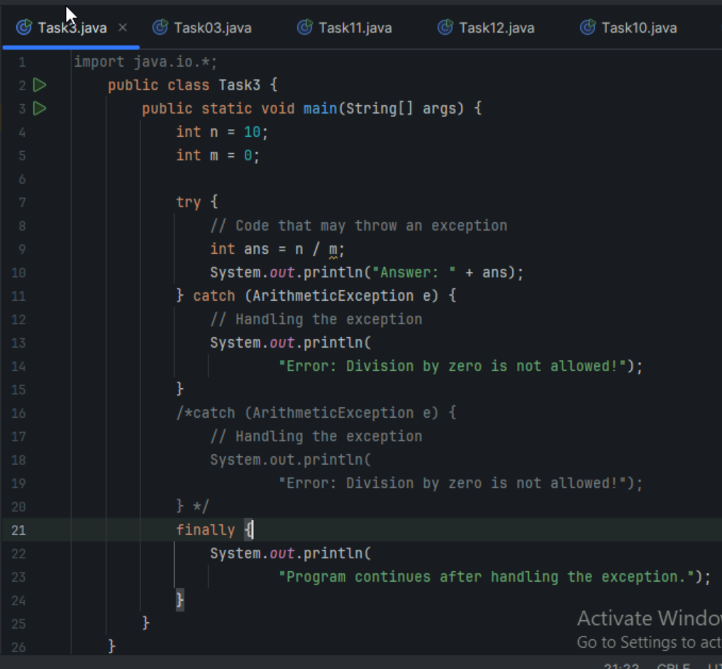
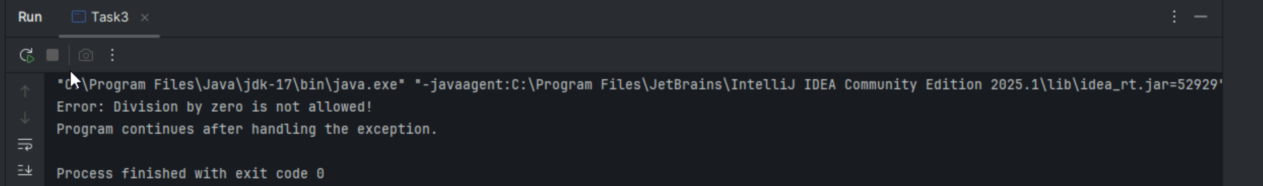

Task 4:

List of checked and unchecked exceptions.
Common Checked Exceptions:
IOException:
This is a base class for exceptions that occur during input/output operations. It's thrown when there's an error reading from a file or writing to a file, or during network communication.
FileNotFoundException:
A subclass of IOException, thrown when an attempt is made to open a file that does not exist.
SQLException:
Thrown when there's an error related to database operations, such as connection problems or invalid SQL queries.
ClassNotFoundException:
Thrown when the Java runtime environment cannot find a class that the application is trying to load.
InterruptedException:
Thrown when a thread is waiting, sleeping, or otherwise occupied, and the thread is interrupted.
InvocationTargetException:
Thrown when a method or constructor invocation fails due to an exception thrown by the invoked method or constructor itself.
CloneNotSupportedException:
Thrown when the clone() method is called on an object that does not implement the Cloneable interface.
Key characteristics of checked exceptions:
Compile-time checking:
The Java compiler enforces the handling of these exceptions. If you don't handle them, you'll get a compilation error.
Recoverable errors:
They typically represent errors that the program can potentially recover from, such as I/O failures or database errors.
Explicit handling:
They must be explicitly handled by the programmer, either by using a try-catch block or by declaring the exception in the method signature.
Here are some common types of unchecked exceptions in Java:
NullPointerException:
This exception is thrown when an attempt is made to access a member of a null object reference.
ArrayIndexOutOfBoundsException:
This exception occurs when an attempt is made to access an array element with an index that is out of the valid range.
ArithmeticException:
This exception is thrown when an arithmetic operation results in an error, such as division by zero.
ClassCastException:
This exception occurs when an attempt is made to cast an object to a class of which it is not an instance.
IllegalArgumentException:
This exception is thrown when a method is called with an illegal or inappropriate argument.
NumberFormatException:
This exception occurs when an attempt is made to convert a string to a numeric type, but the string is not in the correct format.
IllegalStateException:
This exception is thrown when a method is called at an illegal or inappropriate time.
InstantiationException:
This exception is thrown when an attempt is made to create an instance of an abstract class or interface.
SQLException:
This exception is thrown when a database access error occurs.
Error and its subclasses:
These exceptions represent serious problems that a program should not attempt to handle. Examples include OutOfMemoryError and StackOverflowError.
Unchecked exceptions are typically caused by programming errors or unexpected conditions, and it is generally considered good practice to prevent them through careful coding and input validation. However, it is also important to be aware of these exceptions and handle them gracefully when they do occur.

Task 5:

Try with Multiple catch blocks …. Execute the below code snippet n display the out .. along with reason..

public class ExcepTest {

public static void main(String args[]) {
try {
int a[] = new int[2];
int b = 0;
int c = 1/b;
System.out.println("Access element three :" + a[3]);
}
catch (ArrayIndexOutOfBoundsException e) {
System.out.println("ArrayIndexOutOfBoundsException thrown :" + e);
}catch (Exception e) {
System.out.println("Exception thrown :" + e);
}
System.out.println("Out of the block");
}
}
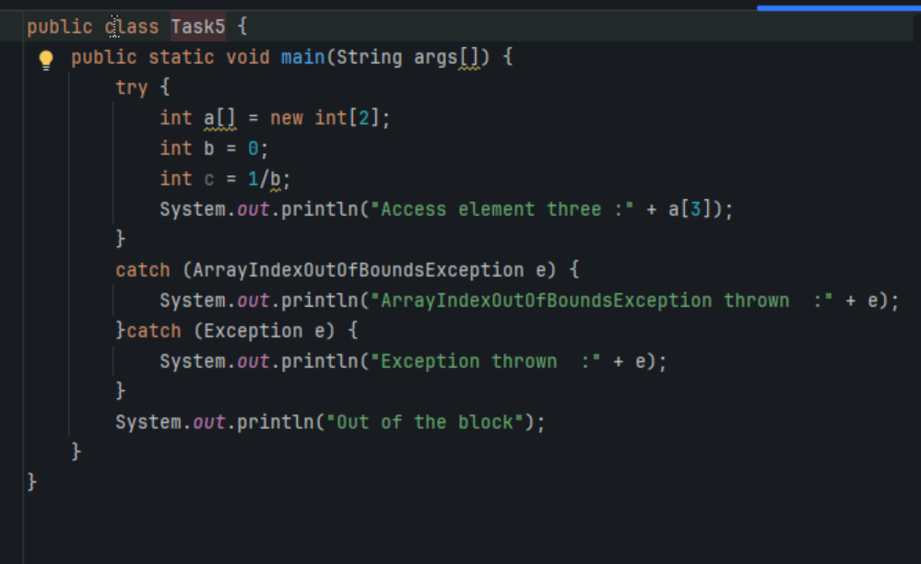

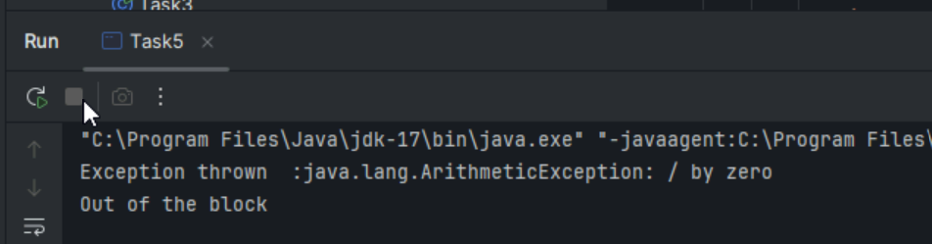

Task 6:

What is the output of the below code… give your reason for the output

public class ExcepTest {

public static void main(String args[]) {
try {
int a[] = new int[2];
int b = 0;
int c = 1/b;
System.out.println("Access element three :" + a[3]);
}
catch (ArithmeticException e) {
System.out.println("ArithmeticException thrown :" + e);
}
catch (ArrayIndexOutOfBoundsException e) {
System.out.println("ArrayIndexOutOfBoundsException thrown :" + e);
}catch (Exception e) {
System.out.println("Exception thrown :" + e);
}
System.out.println("Out of the block");
}
}
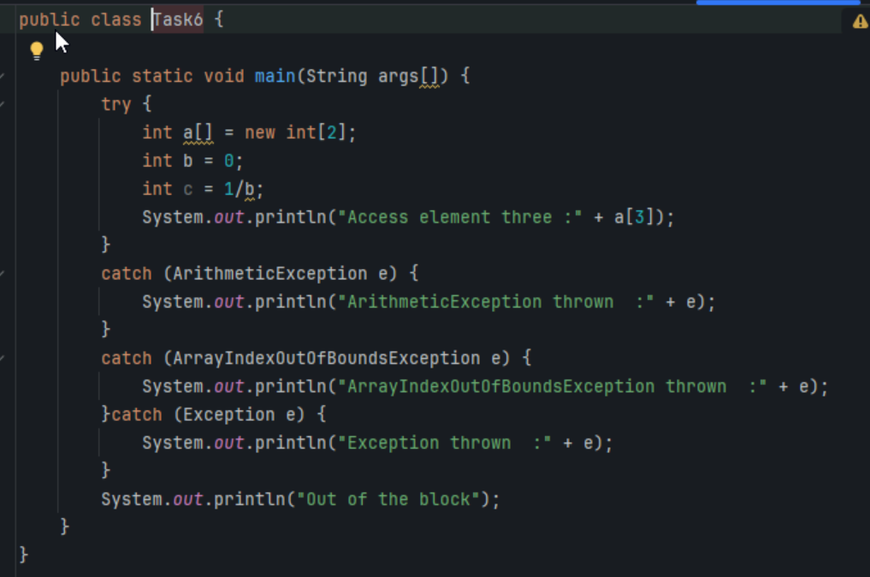
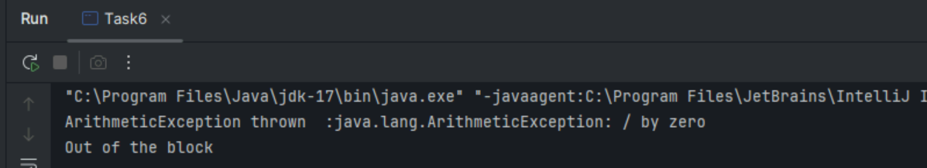
Task 7:

In the below code we are having use multiple catch in a single statement: find the output and try to understand the code..

public class ExcepTest {

public static void main(String args[]) {
try {
int a[] = new int[2];
int b = 0;
int c = 1/b;
System.out.println("Access element three :" + a[3]);
}
catch (ArrayIndexOutOfBoundsException | ArithmeticException e) {
System.out.println("Exception thrown :" + e);
}
System.out.println("Out of the block");
}
}
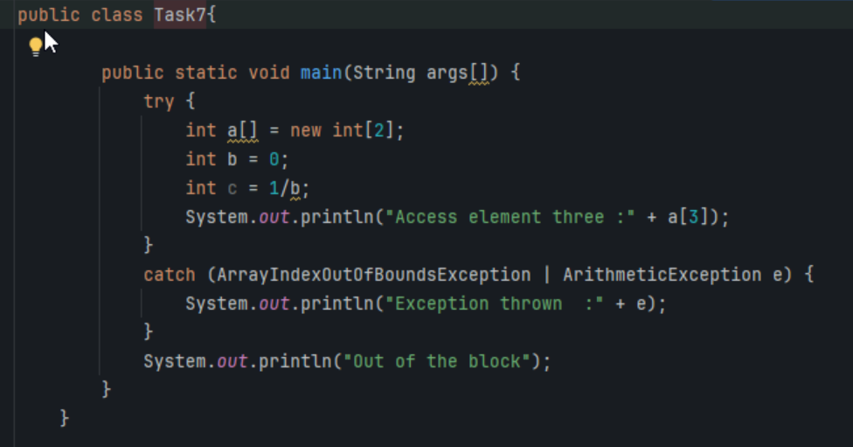
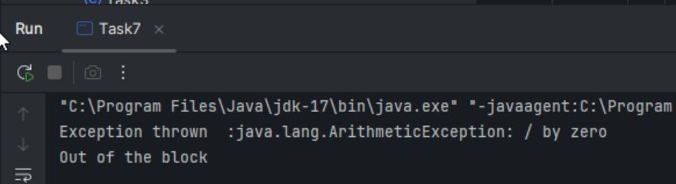
Task 008:

public class ExcepTest {

public static void main(String args[]) {
try {
int a[] = new int[2];
try {
int b = 0;
int c = 1/b;
}catch(Exception e) {
System.out.println("Exception thrown: " + e);
}
System.out.println("Access element three :" + a[3]);
}
catch (ArrayIndexOutOfBoundsException e) {
System.out.println("Exception thrown: " + e);
}
System.out.println("Out of the block");
}
}
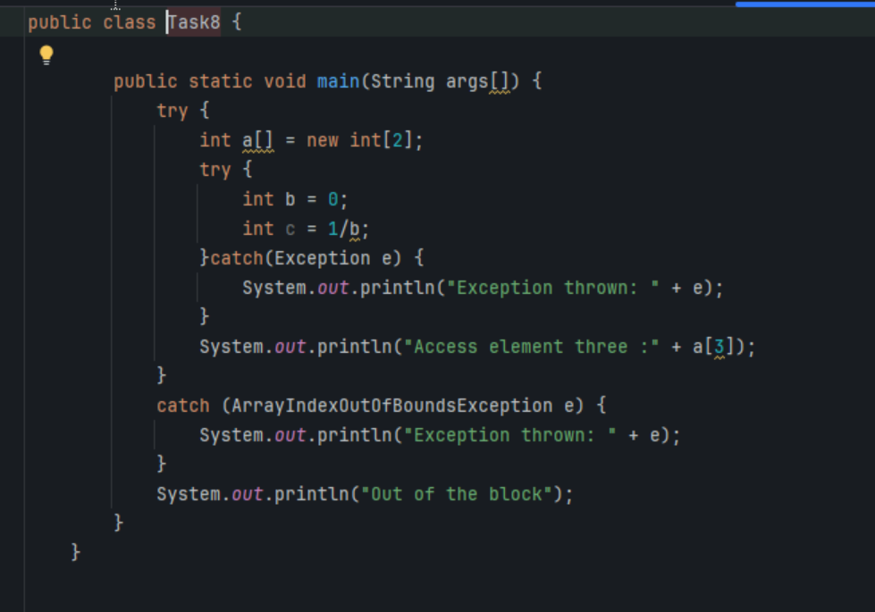
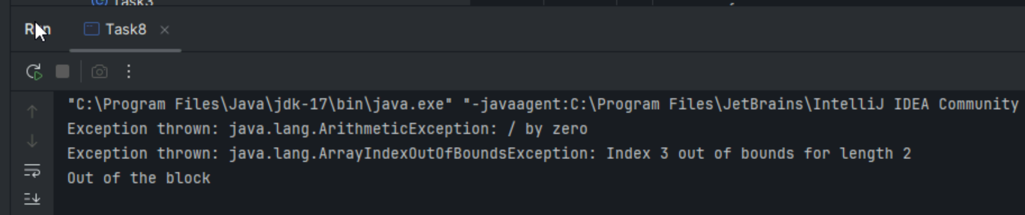
Throw and Throws:

Task 009

// Demonstrating how to throw an exception
class MyClass {

static void fun() throws IllegalAccessException
{
System.out.println("Inside fun(). ");
throw new IllegalAccessException("demo");
}

public static void main(String args[])
{
try {
fun();
//method2(); → arrayindex…
//Method3() —> file not found….
}
catch (IllegalAccessException e) {
System.out.println("Caught in main.");
}
}
}
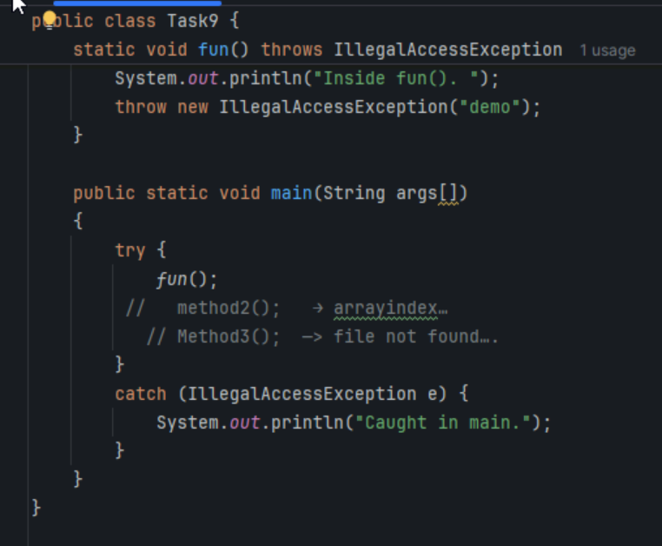
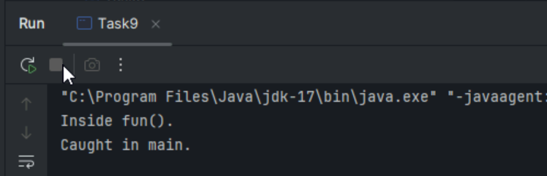
Task 10. import java.util.ArrayList;
class Main {
public static void main (String[] args) {

// Creating an ArrayList
ArrayList<Integer> a = new ArrayList<Integer>();
// Adding Element in ArrayList
a.add(1);
a.add(2);
a.add(3);

// Printing ArrayList
System.out.println(a);
}
}
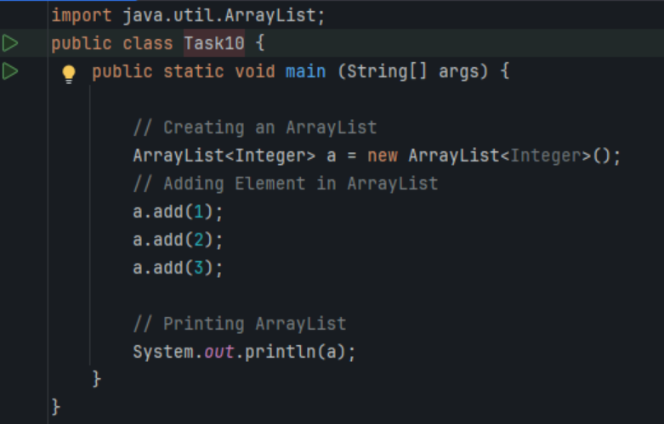
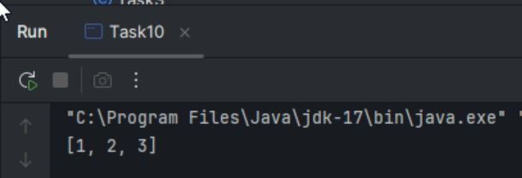

Task 011
Wap to create an array list to display 10 elements using for loop.
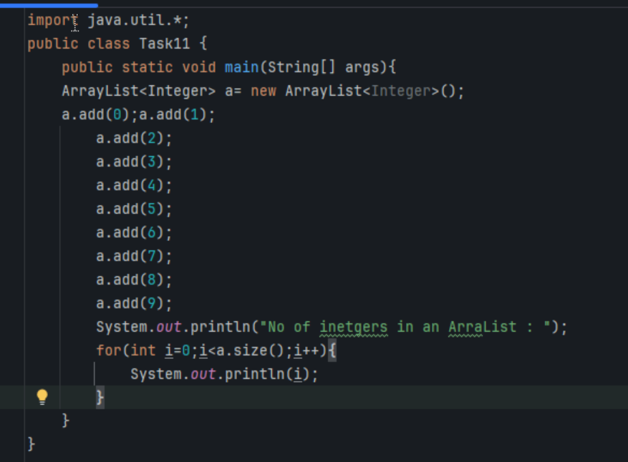
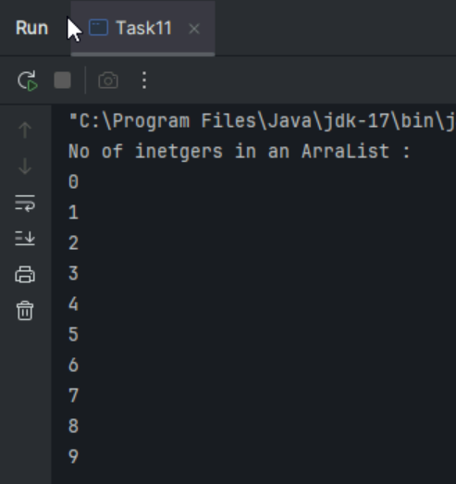
Task 012
Find the output of the be code snippet..
// Addition, Deletion and Updation of Element
import java.util.*;
class Main {
public static void main(String args[]){
ArrayList<String> al = new ArrayList<>();
al.add("Prasunamba");
al.add("Meher");
System.out.println("Orignal List : "+al);

al.add(1, "Hello");
System.out.println("After Adding element at index 1 : "+ al);

al.remove(0);
System.out.println("Element removed from index 0 : "+ al);

al.remove("Prasunamba");
System.out.println("Element Prasunamba removed : "+ al);

al.set(0, "K");
System.out.println("List after updation of value : "+al);
}
}
